Website Recommendations

Home Page

HERO
CURRENT SET UP


- REPLACE Breathe Africa Differently hero banner copy with Breathe South Africa Differently
- REPLACE
Curated group tours, luxury heritage travels and cultural escapes — crafted with comfort, community, and soul. Join the waitlist to be first when we launch.
With
Premier small-group journeys for discerning travelers who expect more than the ordinary.
[Button: Join the Founders Circle → ]
(Note on destination: Users will be directed to the Founders Circle Landing page to learn more about the perks and signature journey)
“https://umoyaafrikatours.co.za/founders-circle/”

ABOUT UMOYA
REPLACE CURRENT SET UP:
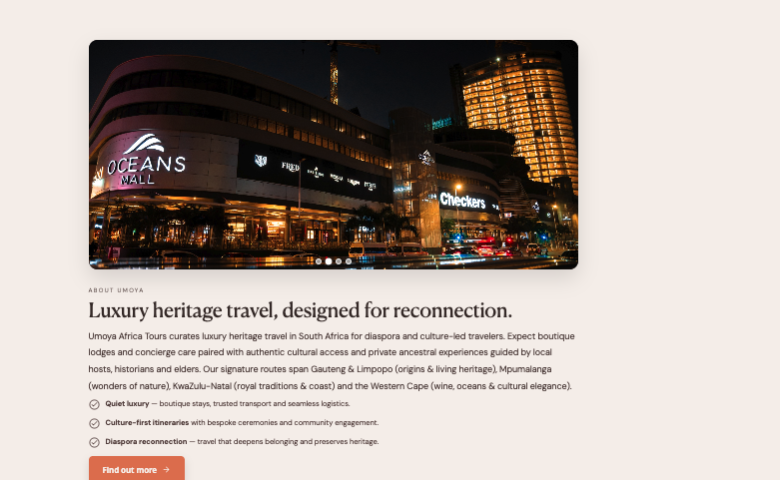
With PROPOSED LAYOUT: (A&K example)
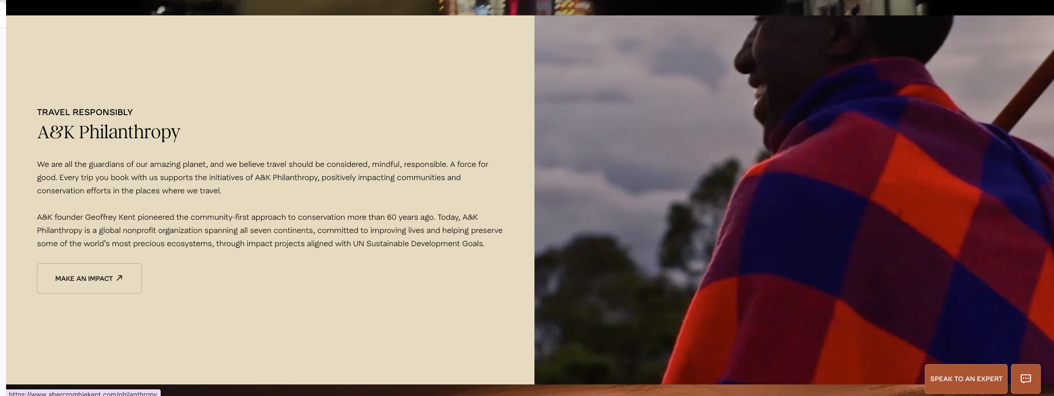

- Replace Luxury heritage travel, designed for reconnection with Move Beyond the Familiar. Step into the Extraordinary.
- Add right-aligned image: Image 1 (crop out her legs)
- REPLACE the content in this section with the following:

Move Beyond the Familiar. Step into the Extraordinary.

At Umoya Afrika Tours, we don't just take you to South Africa. We bring you deeper.
Every journey is shaped by on-the-ground local expertise and genuine cultural perspective, offering access to moments, people, and places that most travelers never encounter. We move with intention and attentiveness, honoring the places we visit and the people who call them home.

Nothing is left to chance. Every detail considered. Every moment crafted to feel effortless.
The result isn't just a trip. It's an experience you'll carry with you long after you leave.

JOURNEY (Top-level)
REPLACE CURRENT SECTION PROPOSED NEW LAYOUT FROM ASHLEY
(Example from Angama for slideshow of itinerary)

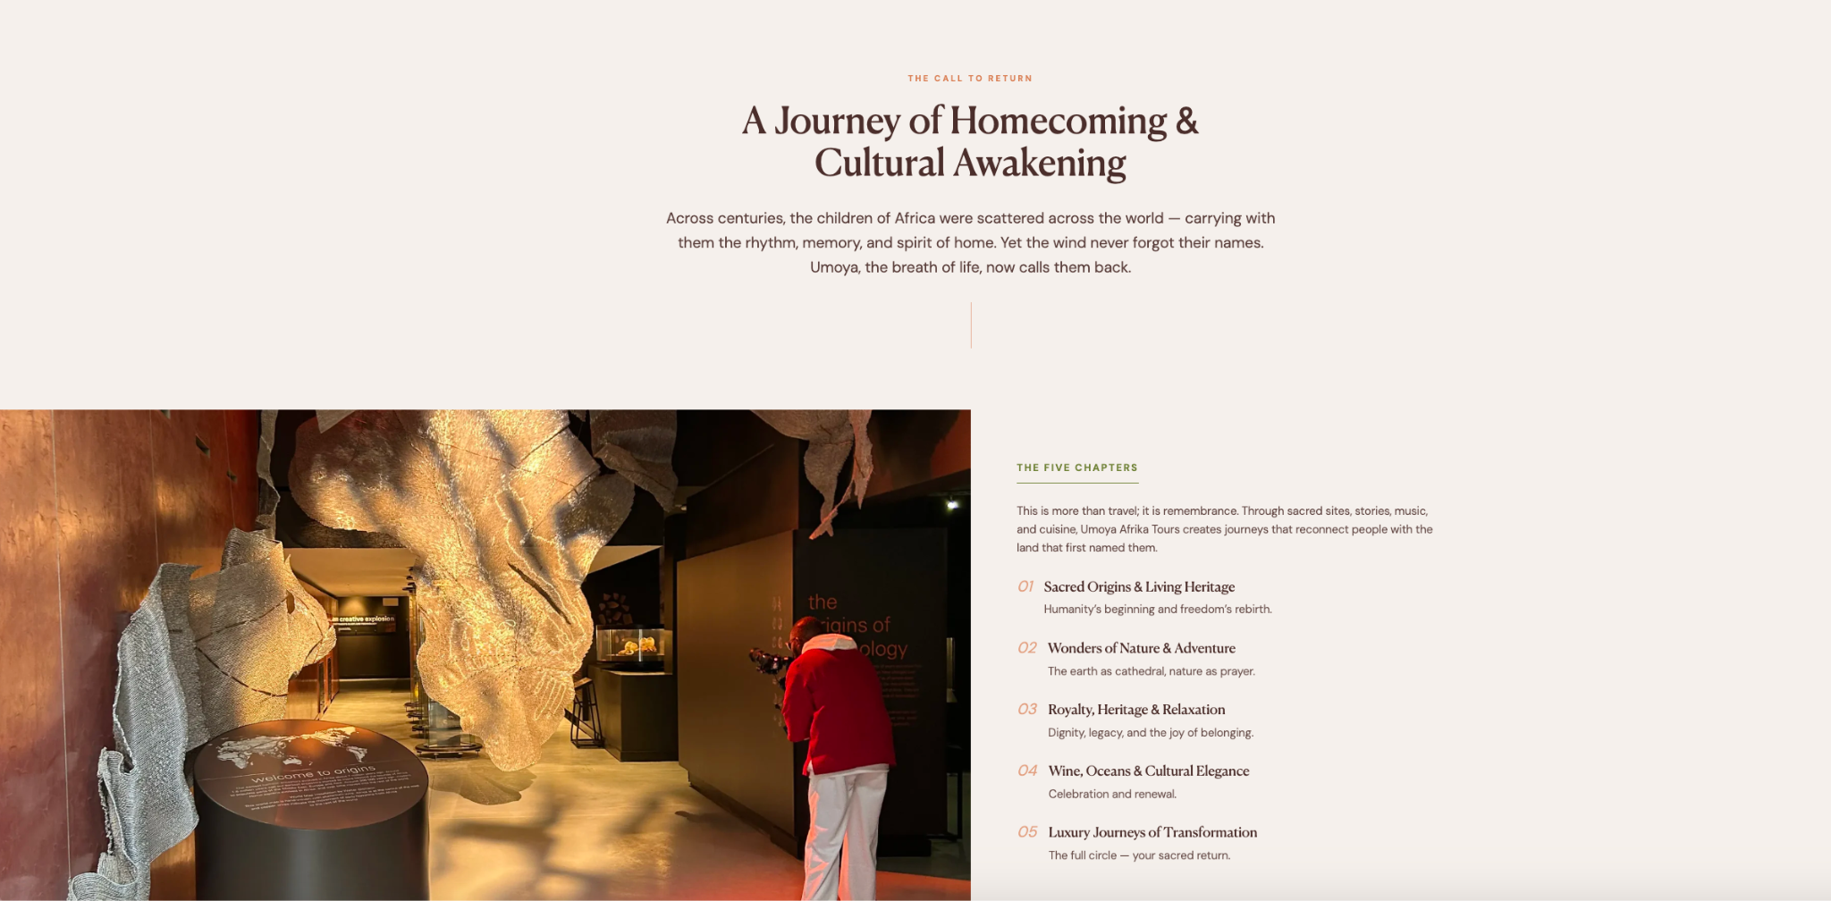 | 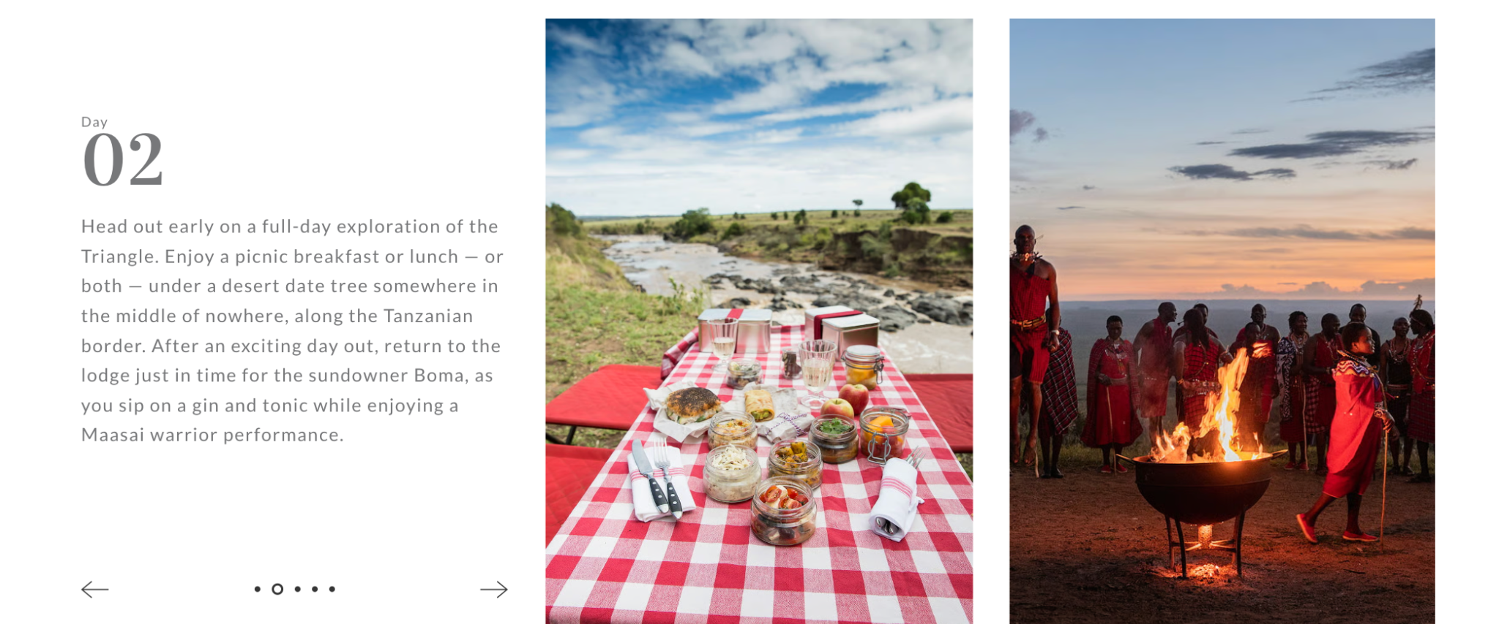

- Replace header: A Journey of Homecoming & Cultural Awakening from Journey into the Heart of Africa
- Add carousel with images and text below
- Replace copy for this section entirely with the following content below

A Journey into the Heart of South Africa
INAUGURAL JOURNEY
15 Days | 4 Provinces | 16 Guests Max

The Umoya Signature Journey moves from the living history of Johannesburg and Soweto to the ancient landscapes of Mpumalanga, the warm coastlines of KwaZulu-Natal, and the creative energy of Cape Town. Each province is explored with privileged local access, private game drives, precolonial heritage sites, and intimate hosted moments that go far beyond the surface of ordinary travel.

[Begin Slide Show: Text appears left aligned with the there is 1 image on the right slideshow and includes more detailed description]

[Slide 1]
Image: 1,
Arrival Day 1 – Johannesburg Welcomes You
Your journey begins the moment you land. A private greeter meets you at O.R. Tambo International Airport and guides you seamlessly through arrival before your transfer into the city.
After settling into your boutique hotel, the evening unfolds at an easy pace. A relaxed welcome dinner offers a first introduction to the group, designed to ease you into the journey ahead.

[Slide 2] Image: 2
Day 2 – History Still Lives in Soweto
Spend the day in Soweto with one of our long-standing cultural partners, whose work is deeply rooted in the community. Moving through Vilakazi Street, Mandela House, and the Hector Pieterson Memorial, the experience is shaped by lived perspective offering context, nuance, and the space to take it all in without rush.
[Slide 3] Image 3

DAY 3 – Johannesburg Beyond the Surface
Begin the day at the Apartheid Museum, with time to move through both the permanent collection and current exhibitions at your own pace. In the afternoon, choose between the Origins Centre or Freedom Park depending on your interest. The evening remains open, or you may opt into a curated dinner with a small group of local creatives and entrepreneurs.
[Slide 4] Image 4
Day 4 – Where the Mpumalanga Landscape Opens
Travel north into Mpumalanga along the Panorama Route, where the landscape begins to open dramatically. Stops at Blyde River Canyon, Bourke's Luck Potholes, Sudwala Caves, and Lisbon Falls are paced for time and perspective rather than quick viewing. By late afternoon you arrive at your lodge, where the shift from city to bush settles in over a quiet evening.
[Slide 5] Image 5
Day 5 – Ancient Knowledge Written into the Land
Visit Inzalo ye Langa, a precolonial stone calendar site that reflects early systems of knowledge tied to land, seasonality, and the sky. The experience offers a different lens into the region's history, grounded in place rather than retelling. After lunch, return to the lodge for an unstructured afternoon; time to rest, reset, or take in the surroundings at your own pace.
Be among the first to experience South Africa differently.

- Please add pricing section like the example above from the Founder’s Circle
- Instead of a built in form, we’d like the button to open up to a pop up form that looks like the example from the Founder’s Circle page below:

[Pop up form with same details from FC page form example below except it will pop out and not be embedded. This form already exists as a html file, C:\Users\MOVING_SURFACE\Downloads\UM_Claude\section-02-form.html”, so bring this in as a pop up and have every section that requires it use it in a popup mode, but don’t duplicate multiple times, just bring it in once and reference for every other section]
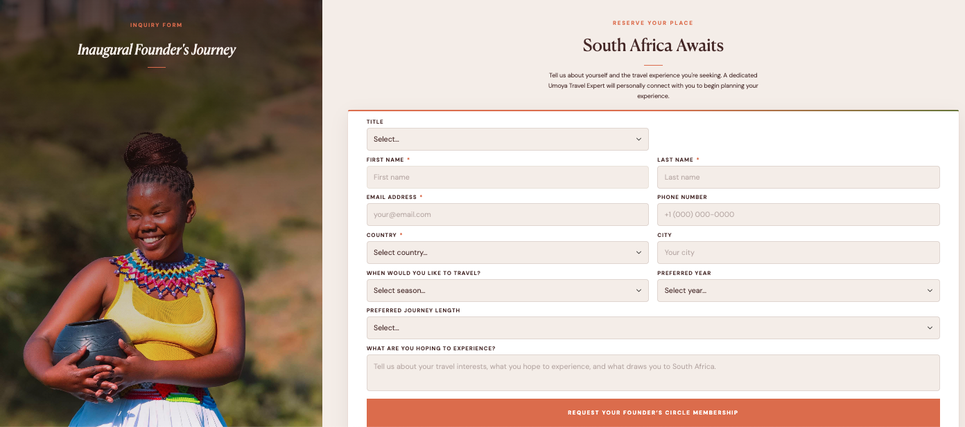
- Instead of Button text saying “Request Your Founder’s Circle Membership” let’s make it“ Speak to an Expert”

BORDER
CURRENT VERSION:
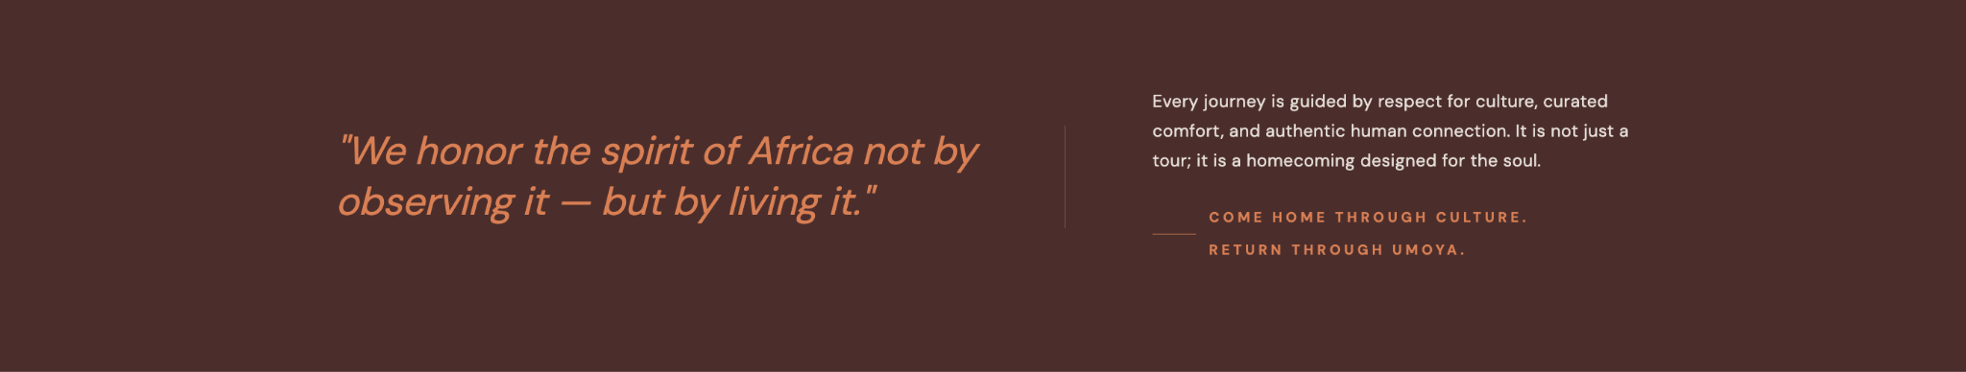
- Add background image
- REPLACE
Every journey is guided by respect for culture, curated comfort, and authentic human connection. It is not just a tour; it is a homecoming designed for the soul. – Come home through culture. Return through Umoya.
WITH
Be among the first to experience South Africa the Umoya way.

Our Founder's Circle is an intimate group of founding travelers who will shape the journey before anyone else with exclusive access, preferred rates, and a seat at the table as we build something extraordinary together.

[Button: Reserve Your Place]

ACCOMODATIONS
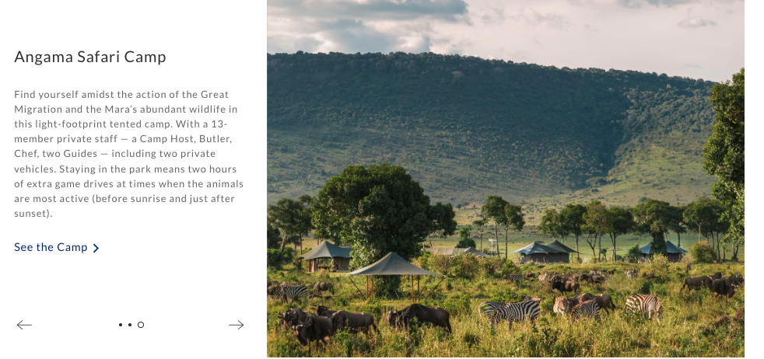
- Add new Section for Accommodations using the format above:
  - Swap copy for new copy below
  - Keep the format pictured below
  - Add Carousel images of accommodations (Images coming soon)
  - Replace subtitle Where you’ll stay with Accommodations

Title: Where Luxury Feels at Home
[Please use the following layout for this brand new section above from Angama]

Image 1, 2, 3, 4

Subtext: Umoya Afrika Tours pairs refined comfort with a deep sense of peace. Guests stay in carefully selected boutique lodges and luxury accommodations that reflect the beauty and character of South Africa’s landscapes.

Every stay is designed to offer both relaxation and immersion, welcoming travelers to experience the continent with comfort, intention, and care.

[Button: Inquire Now]

